
Khwaja Yunus Ali Medical College & Hospital
Enayetpur, Chauhali, Sirajganj-6751

Department of Obstetrics & Gynaecology Date: 17/06/2026

Notice
Card final examination notice for 5th year MBBS, Batch KYA-18(C)

Subject | Date & Time
Obstetrics & Gynaecology (Clinical&Oral) | 18.06.26 ( 9:30am-11:30am)

Eligibility Criteria:
- ≥75% attendance in clinical class.
- All items are cleared.

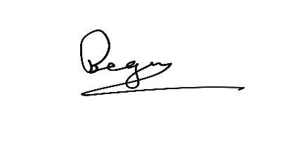
……………………………….
Prof. Dr. Parvin Rahman
Head of Dept. of Obstetrics & Gynaecology
Khwaja Yunus Ali Medical College & Hospital
Copies are forwarded for kind information and necessary action please to:
- Principal, Khwaja Yunus Ali Medical College
- Vice Principal, Khwaja Yunus Ali Medical College
- Medical Education Unit
- Academic Coordinator, Phase-IV Coordinator, Khwaja Yunus Ali Medical College
- Notice Board
- Office Copy

