
Khwaja Yunus Ali Medical College & Hospital
Enayetpur, Chauhali, Sirajganj-6751

Department of Obstetrics & Gynaecology Date: 26/02/2026
MBBS 5th Year (KYA-18) Ward Placement
Group-A | Group-B | Group-C
05.09.26-16.10.26 | 04.07.26-14.08.26 | 02.05.26-19.06.26

Day | Morning (9AM-11AM) | Evening (4PM-9PM)
Saturday | Routine Obs & Gynae  Asst. Prof. Dr. Roksana Nazim  or Registrar | Labour Room  Asst. Prof. Dr. Rukhsana Pervin  or Registrar
Sunday | Routine Obs & Gynae  Asst. Prof. Dr. Rukhsana Pervin  or Registrar | Labour Room  Asst. Prof. Dr. Aeysha Begum  or Registrar
Monday | Routine Obs & Gynae  Asst. Prof. Dr. Aeysha Begum  or Registrar | Labour Room  Asst. Prof. Dr. Roksana Nazim  or Registrar
Tuesday | Integrated teaching | Labour Room  Assoc. Prof. Dr. Mujibur Rahman  or Registrar
Wednesday | Integrated teaching | Labour Room  Prof. Dr. Parvin Rahman  or Registrar
Thursday | Routine Obs & Gynae  Assoc. Prof. Dr. Nasrin Nigger  or Registrar | Labour Room  Assoc. Prof. Dr. Nasrin Nigger  or Registrar

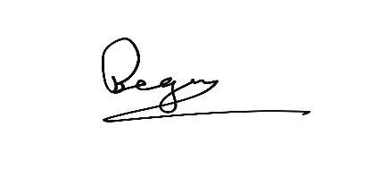
……………………………….
Prof. Dr. Parvin Rahman
Head of Dept. of Obstetrics & Gynaecology
Khwaja Yunus Ali Medical College & Hospital

Copies are forwarded for kind information and necessary action please to:
- Principal, Khwaja Yunus Ali Medical College
- Vice Principal, Khwaja Yunus Ali Medical College
- Academic Coordinator, Phase-IV Coordinator, Khwaja Yunus Ali Medical College
- Medical Education Unit
- Notice Board
- Office Copy

